, .

COLONIAL FOOTBALL OFFICIALS ASSOCIATION

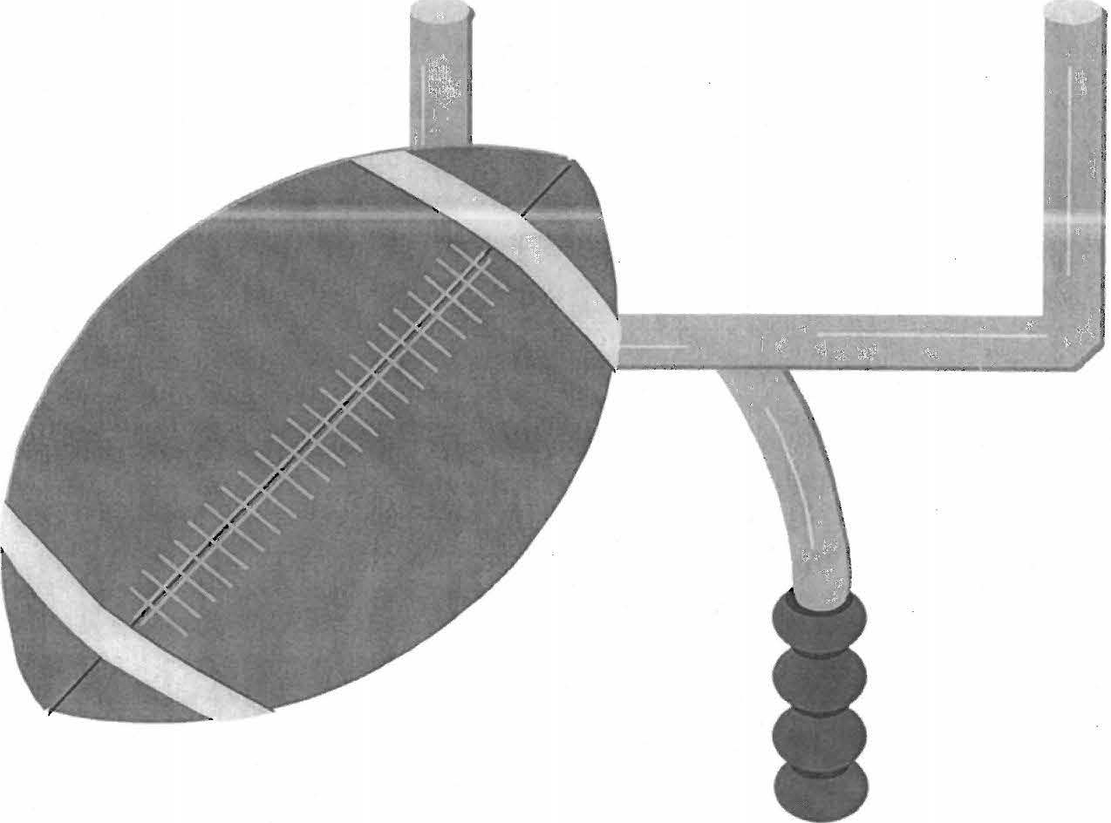
I

THREE-MAN MECHANICS MANUAL

•

REFEREE

As the Game Administrator, you must have the crew ready to work the game. A solid pre-game conference is essential to a smooth flow of the game. It is essential that the crew has confidence in you and you have confidence in the crew. Go over the basics, basics and more basics. Ninety-nine per-cent of what will happen on the field today will be just that - BASIC. As the season progresses you can cover additional items that might have occurred the previous week either with your crew or with someone else's crew. Leadership and control are critical to the successful administration of the game. This begins when you and the umpire visit with the opposing coaches before the game. Some coaches may ask you about a specific situation with regard to this game or will question something that happened to them last week. Answer the question that pertains to this game. If you were not officiating for that coach the previous week politely tell him that you had no knowledge of what happened and it would be unfair to comment unless you observed the specific play in question. Once on the field remember one thing -"No one has a better job on this particular day then you -and- the crew that will be working this game with you today." Enjoy the next 2.0 to 2.5 hours.

SCRIMMAGE PLAYS

- Using a demonstrative signal, blow your whistle declaring the ball ready for play when standing approximately 2 yards deep and 2 yards wide of the offense’s huddle.
- Make sure your initial position is approximately 5 yards deeper than the deepest back and on the QB’s throwing arm. Be on the outside shoulder of and as much as one yard wider than the tight-end position on your side. This position should allow you an excellent peripheral view of the action.
- Always check with HL on down and distance before each down. If there is any doubt stop the game and verify it with the official statistician before moving on to the next down
- Count the offensive players (If possible count offense while in the huddle, this will help with any substitution violations)
- Backfield responsibility prior to the snap and then key guard, center, guard.
- Ball carrier responsibility until runner reaches the line of scrimmage. Kill plays that end deep in the offensive backfield. Look to your wingmen to assist you with forward progress on sacks.
- Primary responsibility of spotting ball
- 25-second count responsibility
Areas of responsibility:
- Ball, runner and action around him to neutral zone.
- If action is toward linesman: Do not follow runner too closely moving parallel to scrimmage line behind runner.
- Do not get boxed in. Do not turn back on ball.
- Be ready for kick or pass which may start out as running play.
- If there is a score and no foul which might nullify score, give touchdown signal and record score.

Check following:
- Illegal use of hands by players of A.
- Action behind ball and away from runner near neutral zone.
- Action on quarterback after hand-off.
- Blocks on your side of ball outside free-blocking zone toward ball.
- Backward or forward pass when ball is thrown.
- Fouls behind runner after he crosses neutral zone.
- Continue to observe action behind neutral zone before leaving area.
- Responsible for runner until he crosses neutral zone or turns up field.
When ball is dead:

- Move quickly to its location.
- Be positive of ball location before sounding whistle.
- Spot the ball, declare ball ready-for-play by using established procedure and sound whistle.
- If first down has been made or change of team possession has occurred, give time-out signal to stop clock, unless already stopped by rule and give first-down signal.

FREE KICKS

Before kick:

- Position is near R’s 10-yard line in center of field. Or deeper than deepest receiver
- Count R players.
- Check positions of other officials.
- After ready signs have been received, drop arm and sound whistle to signal that kick be made.

If short, free kick is anticipated:

- Take regular position, staying deeper than deepest receiver.
- Be alert to assist other officials.
After kick:
Kick down the middle:

- At the time of the kick, rule on whether a minimum of four players were on each side of the ball. If this is not the case, blow whistle, throw flag and kill the play
- Signal clock to start when kick is touched, other than first touching by K
- Pick up runner and follow until releasing to linesman or umpire.

Deep kick:

- Retreat to goal line to rule on touchback.
- If kick is caught inside 5-yard line and player is downed in end zone, or ball goes out of bounds there, mark spot of catch with bean bag and rule on whether player’s momentum took him into end zone.
- Move cautiously with play watching action around the runner.
- Observe action of other players in vicinity of
- Kick out of bounds, determine if R had touched or last touched ball inbounds.

SCRIMMAGE KICKS

Punts

After ball is spotted:

- Check down and distance with linesman.
- Count K players.
- Declare ball ready-for-play by using established procedure.
- Position yourself on a 45-degree at least 3-5 yards outside the tight-end position and 2-3 yards behind the kicker the kicker’s leg side
- Be able to see ball and observe all backs.

After snap:

- Watch for roughing the snapper.
- Watch for fouls behind neutral zone especially near kicker.
- If low snap, rule on whether Kicker’s knee touches ground, if snap is over Kicker’s head, go with the ball
- Be alert for blocked kick and be ready to rule on recovery.
- After ball crosses the neutral zone, observe line play.
- Move downfield slowly following kick.
- Watch for fouls and be ready to pick up runner if there is long return – goal line responsibility.
- Once the ball is kicked, move to position where ball was kicked watching flight of kick if kicked toward sideline. Be ready to line up covering official to OOB spot if ball leaves field on the fly.

Field Goals/Extra Points

- Position directly behind ball to cover acts in vicinity. Be able to see holder receive ball.
- On extra point only, blow whistle when ball is kicked. On FG attempts make sure ball cross goal line prior to blowing whistle. If ball does not reach goal line, ball is live
- Count K players.
- Judge whether kick goes between uprights.
- Check with LJ whether ball has crossed over crossbar

RUNS

- Between the ends, be aware of blocking at the POA and officiate around the area of the ball carrier.
- The HL and LJ will kill most runs and give forward progress.
- On wide runs, move toward the side zone behind the action, continuing to observe
action around the ball carrier and be ready to assist if any OOB activity occurs.

PASSES

- The QB is your #1 priority, and must be protected from all illegal actions by defensive players. Stay with him as long as he is in any danger. Do not allow the defender more than one step after the QB releases the ball prior to the defender contacting the QB. Back pedal at an angle-not-straight back
- While you are primarily responsible for the offensive tackle on opposite side, observe all blocks behind the line of scrimmage
- Determine whether pass is forward or backward, after quarterback drops back
- Assist on whether passer’s feet were in or behind line of scrimmage when ball was released. Move to spot of pass, if illegal drop penalty flag, if close, mark spot of pass with bean bag and continue officiating
- Solely responsible for intentional grounding, may get assistance from covering official
- On both running and passing plays, look for fouls that have a large effect on the play, (e.g., the little pull that makes the play, the takedown or pull back (snatch) by the blocker for the QB

PENALTY ENFORCEMENT

- Give preliminary signal to press box (not needed for dead ball fouls prior to the snap) on fouls as soon as it is reported. DO NOT LET ANY PLAYER OR OFFICIAL DISTRACT YOU WHILE YOU ARE DOING THIS.
- Do not move any distance before doing this, but step out in the open and give it.
Maintain a stationary base; be firm on signals-no loose signals.
- Gather information and direct line judge to proceed with enforcement once option is obvious or after consulting with offended team.
- If there is a disagreement or uncertainty on a call or penalty enforcement, do not hesitate to conference with specific officials involved in the call.
- Give final signal to press box
- If there is any confusion or unusual circumstances with the interpretation, make sure you go to both coaches, with another official in presence to provide the final determination
- It is not how we look that is important; it is of utmost importance to GET THE CALL RIGHT.

HEAD LINESMAN & LINE JUDGE

You are primarily responsible for dealing with the coaching staffs on your side of the field. During the game the action can get quite heated and it is important that you maintain a professional approach. Remember the game is emotional and you are there to arbitrate and not to root for or root against. Let the coach have his say and NEVER meet emotion with emotion.

FREE KICKS

Line Judge

Before kick:

- Position is R’s free-kick line outside sideline opposite linesman with beanbag in your hand.
- Monitor bench area, identify the free-kick line for the receiving team, then move quickly to sideline opposite linesman.
- Be certain coaches, players, substitutes and other individuals are in proper location.
- Count R players.
- Hold arm above head to indicate you are ready.
- Watch for any infraction involving R’s free-kick line.

After kick:

Kick to your side:

- Signal clock to start when kick is touched, other than first touching by K.
- Pick up runner and follow – goal line responsibility
- When ball becomes dead, sound whistle and give time-out signal.
- Mark spot where kick goes out-of-bounds on your side of field:
- Drop penalty marker if untouched inbounds by R or not last touched inbounds by R.

Kick to opposite side of field:

- Move cautiously toward play.
- Observe action of other players in vicinity of runner.
- Be alert for first touching by K and mark with beanbag.

Head Linesman

Before kick:

- Take possession of ball
- Position is K’s free-kick line outside sideline opposite line judge with beanbag in your hand.
- Monitor bench area, identify the free-kick line for the receiving team, then move quickly to sideline opposite linesman.
- Be certain coaches, players, substitutes and other individuals are in proper location.
- Count K players. Do not start play until K has correct amount of players on the field
- Ensure all K players are no further then 5-yards behind free-kick spot
- Hold arm above head to indicate you are ready.
- Watch for any infraction involving K’s free-kick line.

After kick:

Kick to your side:

- Signal clock to start when kick is touched, other than first touching by K.
- Pick up runner and follow – goal line responsibility
- When ball becomes dead, sound whistle and give time-out signal.
- Mark spot where kick goes out-of-bounds on your side of field:
- Drop penalty marker if untouched inbounds by R or not last touched inbounds by R.

Kick to opposite side of field:

- Move cautiously toward play.
- Observe action of other players in vicinity of runner.
- Be alert for first touching by K and mark with beanbag.

SCRIMMAGE PLAYS

- Read the offensive formation and know your keys. Look for multiple things as each
play develops. Communicate with one another visually the down before each play.
- On all plays from the line of scrimmage line judge should count defense
- HL and H count to ensure you have 7 offensive players on the line of scrimmage
- Know the approximate distance to go before each play. Indicate the offensive LOS by extended foot, and then take final position straddling the neutral zone, on the sideline. Punch back widest receiver if he is off line. If he goes in motion drop arm.
- Concentrate on the ball and the offensive linemen between you and the ball. See the ball snapped. H and LJ have tackle. Cover man in motion going away from you for illegal motion. He remains your responsibility even though he changes direction (does not relieve opposite official from making obvious call).
- HL - it is your primary responsibility to know the down and distance before the start of each play. Communicate this to the Referee. If there is any discrepancy between the crew, the Referee will check with the official statistician before the next play is · run.
- HL -keep the chain crew a minimum of 2 yards off the sideline where facilities permit.
RUNS

- You are responsible for your half of the field. Take the runner to goal line.
- Give forward progress with sharp 90-degree turns. Assist R with forward progress on sacks behind LOS. Ask for the ball and place at your feet on plays when a measurement may be required. Under no circumstances should the ball be marked without your progress spot!
- Keep the whistle out of your mouth. Don't anticipate. If you don't see the ball in player possession, don't blow your whistle. (A play kills its self, it is okay not to have a whistle on a play)
- If the ball goes OOB, stop at the OOB and observe any OOB action. Never take your eyes off OOB players. The R official should be moving in to clean up and clear out the OOB players.
- If you are the off-wing official, observe action away from you. Move onto the field, ensuring no players are behind, and down field so that you are at the approximate dead ball spot on your side of the field. This spot should only be utilized in the event the opposite official is temporarily out of position and did not have the spot.

Areas of responsibility:

- On quick plays into line, assist referee in marking forward progress with downfield foot.
- Observe initial charge of linemen. Key near tackle for run/pass.
- Observe action by blockers on end and linebackers on your side.
- Pinch in when necessary especially on short yardage for first down and, if possible, on every play within 10-yard line and goal line.
- Be ready to move quickly downfield on quick kick and pass.
- While moving downfield with runner, watch for illegal forward pass or fumble.
- If play continues following an illegal forward pass, drop penalty marker at spot of pass to indicate where run ended and at spot of any subsequent foul.

Head linesman working with line-to-gain equipment and crew:

- Echo referee’s signal verbally and with proper hand signal to move chains
- Do not turn back on field of play when having equipment moved.
- Authorize down marker to be moved only after referee’s signal.
- When necessary to move line-to-gain equipment:
- Spot foremost point of ball with downfield foot.
- Have down-marker operator mark the spot, informing referee that line-to-gain equipment is ready.
- Have line-to-gain crew set the remaining line-to-gain equipment.

When line-to-gain is goal line:

- Instruct chain crew to move chains back and drop to the ground
- Provide down-marker operator with beanbag for goal-to-go situations when the line-to-gain equipment has been removed.

PASS PLAYS

After ball is spotted:

- Position, same as for running play.
- Check down-marker number.
- Identify eligible receivers on your side of line.
- Be alert for shifts that may change eligibility of players.
- Be in position to determine whether a quick pass or pitchout thrown toward you is forward or backward.
- Check player in motion away from you and maintain responsibility for him if he reverses direction.
- Be ready to adjust coverage if passer decides to run.

After snap:

- Observe action of the nearest ineligible lineman and pass protection until the ball is thrown or until your eligible receiver is a possible pass receiver.
- Be alert for defensive holding of eligible receiver.
- Move downfield to cover passes on your side and assist with all deep passes.
- After catch and ball is dead, mark spot and look for first down.

Watch for and be ready to rule on:

- Interference by either team.
- Illegal pass after completion.

After interception:

- Observe action until ball is dead.
- Mark spot (side line responsibility all the way to goal line)
- When runner is down, signal time-out and direction ball will be put in play.

After incompletion in your area:

- Sound your whistle and give incomplete signal.
- If ball is on your side of field, retrieve ball and relay ball to Referee.
- If deep pass to middle or other side of field, assist in ball rotation to Referee.
- If unsure of a call look for help from other officials prior to making a call (go slow)

SCRIMMAGE KICKS

Punts

After ball is spotted:

Head Linesman:

- Position is same as for run or pass.
- Check down number.
- Responsible for knowing if ball crossed neutral zone.

After snap:

- Hold position until ball crosses the neutral zone.
- Cover all kicks to your side.
- Assist referee in covering ball on short or blocked kick: Note if kick is touched beyond neutral zone
- Assist R on action of up-backs in the offensive backfield
- Unless kick comes close to your side delay your movement down sideline, cover fouls in secondary.
- Move with runner if he comes to your side.
- Follow to goal line if run is broken.
- Assist R in knowing if kick is tipped by a player that was blocked into kick.

Ball out of bounds in flight:

- Sound your whistle and give time-out signal.
- Move farther downfield than where it went out.
- Walk up field until referee spots you on sideline.

Ball rolls out of bounds:

- Sound your whistle and give time-out signal and point in the direction of next possession.
- Hold spot and continue to observe action
- Drop beanbag at spot if a ball must be retrieved.
- Note if recovered in or behind neutral zone.

Routine kick:

When ball becomes dead:

- Sound whistle, give time-out signal, and mark spot.
- Make sure of possession on fair catch.
- If there is a foul, free official cover ball while official who had foul reports information to referee.
- Watch referee for signal to move line-to-gain equipment

Line Judge

- LJ count receiving team.
- Take basic position 10-12 yards wider and 2-3 yards behind deepest receiver on your side of the field
- On kicks to your sideline that goes OOB's in flight look to R to line you up.
- Have white beanbag in your hand to mark spot if ball is illegally touched in your area or the ball goes OOB on your sideline.
- Use blue beanbag to indicate spot where kick has ended
- Be alert for muffs and fumbles.
- After play becomes dead appropriate official will indicate the result of play (i.e., illegal touch and/or signal direction). This will alert all others and give R a chance to digest play.
- Be aware of kicking team players going OOB and returning.
- LJ- Look to R to line you up on all punts that go OOB's in the air to your side of the field

Kick caught inside 5-yard line and player downed in his end zone:

- Mark spot of catch with beanbag.
- Be prepared to rule if momentum took him into end zone.

Kick down middle or to your side:

- Move quickly downfield.
- Cover action around the ball.
- Pick up runner if kick is returned

Field goal/Extra Points

- Position is same as scrimmage play
- If breakdown, officiate as if it is a regular scrimmage play
- When play is blown dead, move in to clean up and clear out players
- If play is busted or a fake make a beeline for the pylon on your side of the field to rule.
- Know your eligible
- After kick, HL responsible for kicker holder
- After kick LJ responsible for ruling on whether ball has gone over or under cross bar
- After kick, come to middle of field to clean up

PENALTY ENFORCEMENT

- Obtain all details of the foul before you approach the Head Coach on your side.
- Communicate to the Head Coach the foul and other pertinent information in a slow,
concise and professional manner.
- Be sure to answer any questions he has if you know the answer to them. If you do not tell him you will get back to him.
- LJ will have primary responsibility to walk of penalty enforcement
- If enforcement of penalty will create or be close to a first down, HL should check the five-yard marker (tape) on chain prior to offering choices to captain

CLOCK ADMINISTRATION

- LJ has the clock
- Make sure you communicate with R in starting the clock properly.
- If game clock is present- be sure all know official time is on the field
- On penalties make sure that it is stopped.

GENERAL

- Do not converse with crowds at any time before, during or after game intermissions.
- Be in top physical condition. The players work hard, the coaches work hard and they deserve our best.
- Don't be over officious. Fans come to watch the players play and not to see officials
officiate!
- If you have a foul make sure you KILL THE CLOCK!!
- Don't' ever criticize or attempt to explain another official's judgment on decisions to a coach, team or fans. Never argue with players. If a player asks a question, give him the courtesy of listening to it, and then give a definite and decisive answer. Never quibble about any situation.
- Do not discuss with any coach the play or players of his opponents in a game that you
will officiate or are officiating.
- If a ruling is puzzling, relay an explanation to BOTH coaches.
- Assist players in the interpretations of rules when such request is made at the proper time.
- Wear your best and look best at every game.

